bring bags to the grocery store

The options for dominance are

* Scale
* Value
* Color
* Style
* Proximity
* Density

I think my project would be utilize scale, style, and color. It’s possible that my image could be predominately white and green, so maybe proximity can help pull focus better than color, depending on my actual design.

If the colors are all similar then I think proximity will make something stand out instead. But overall, style and scale will definitely be helpful in my project.

plastic bags

paper bags

reusable bags

backpacks

earth

sustainable

responsible

laziness

green

food

Pitt students

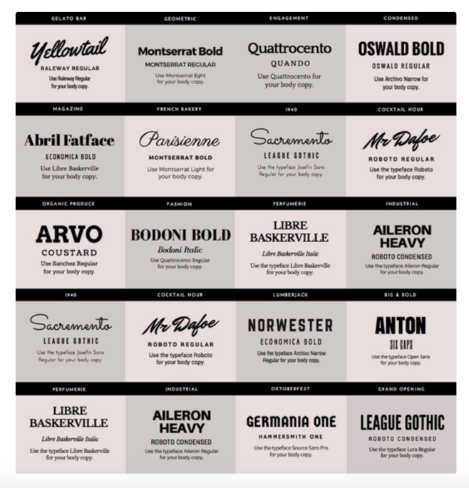

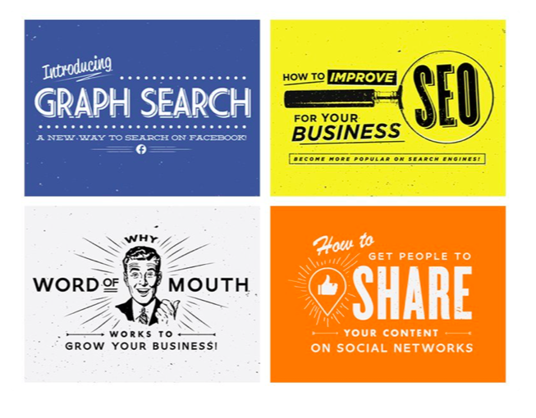

ASSETS

Pictures:

bag by Turkkub from the Noun Project

plastic bag by HeadsOfBirds from the Noun Project

Plant by Mateo Zlatar from the Noun Project

Plant by Ale Estrada from the Noun Project

Photo by [Andreas Gücklhorn](https://unsplash.com/@draufsicht?utm_source=unsplash&utm_medium=referral&utm_content=creditCopyText) on [Unsplash](https://unsplash.com/s/photos/earth-background?utm_source=unsplash&utm_medium=referral&utm_content=creditCopyText) (earth background)

Info:

https://plasticoceans.org/the-facts/